EXPERIMENT NO 2

Case study on Quality Management of Tata Motors

**Name of the Student: Devansh Upadhyay**

**Roll No: 52**

**Program: B. Tech CSBS Sem: VIII**

**Batch: 3**

**Date of Experiment: 11-3-24**

**EXPERIMENT NO 4**

**Case Study:**

Automotive OEMs adheres to Quality process in a bid to continuously improve in their working efficiency, minimize the Cost of Poor Quality (COPQ) and improve the product line enabling them to become market leaders thus improving brand value and never the least adhere to the quality compliances set internally or by the government agencies. Total Quality Management (TQM) is not a new process and emphasizes on various concepts involving Customer focus, Continuous Improvement, Employee Empowerment, Product Design & Tools and Managing Supplier Quality. In this paper, we present a case study of how Tata Motors Ltd (TML), an Automotive OEM giant in India, has successfully implemented Supplier Quality Management (SQM) seamlessly integrated in its current manufacturing processes. It should be noted that TML started Supplier Quality Improvement Program (SQIP) encompassing the 360 degree process of supplier quality management starting from profiling and onboarding vendors – collaborating with vendors for design and validation of parts – working along with vendors for Production Part Approval Process (PPAP) – and finally collaborating with vendors for current quality process.

Since 1950, quality has received global attention in Automotive manufacturing and OEMs like Toyota, Ford Motors, General Motors etc. have been spending money to achieve efficient quality processes in their manufacturing units. Girish Wagh, Head Passenger Vehicle, Tata Motors Ltd. says “India has made its mark within the automotive industry and has become a manufacturing hub for multinational OEMs. India has also earned itself a reputation for manufacturing worldclass vehicles at lower costs.” To sustain its brand image, Tata Motors Ltd. (TML), an automotive manufacturing OEM, committed itself to producing world class quality cars at competitive cost. Tata Motors Ltd. (TML), has six big manufacturing plants (Jamshedpur, Pune, Lucknow, Dharwad, Sanand, Pantnagar) across India and took a big leap while designing Supplier Quality processes to bring all suppliers for commercial and passenger vehicles in one unified umbrella. For quite a while, TML had been rolling out various initiatives within the organization to eliminate waste, reduce cycle time and increase productivity. These objectives however fall short of target, if the supply chain is not fully engaged with these initiatives. It is then that Supplier Quality Improvement Program (SQIP) was introduced in TML for Passenger Car Business Unit (PCBU) to help achieve business objectives. The SQIP program had many departments integrated seamless within the process to ensure successful implementation of Supplier Quality like Engineering Research Center (ERC), Vendor Development (VD), Supplier Quality Improvement Group (SQIG) and Suppliers. In this paper, we will go through the SQIP process defined by TML SQIG team and the different digital web applications developed by TML IT team to support the SQIP process.

SUPPLIER QUALITY IMPROVEMENT PROCESS (SQIP)

The TML SQIP process is divided into 5 phases and 16 process steps as given in diagram below:

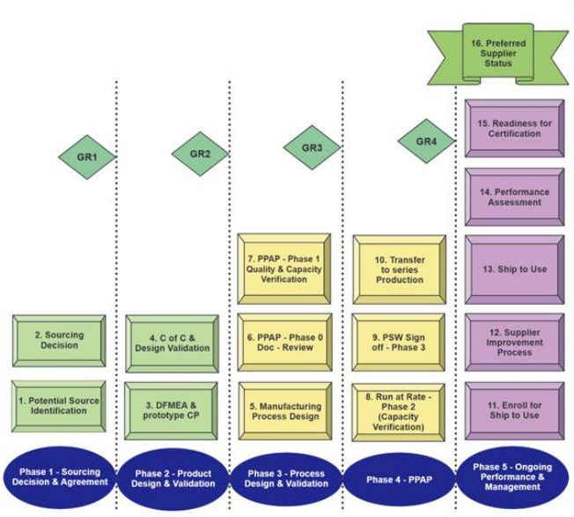

Source: Supplier Quality Improvement Program (SQIP) Manual, Tata Motors Ltd

Phase-1: Sourcing Decision and Agreement

Depending on the type of business or product being analysed, a company will use various inventory management methods. Some of these management methods include just-in-time (JIT) manufacturing, materials requirement planning (MRP), economic order quantity (EOQ), and days sales of inventory (DSI).

There are others, but these are the four most common methods used to analyze inventory. Usually, in automotive manufacturing organization it is always a need to develop primary and/ or secondary supplier(s) to ensure uninterrupted supply of part(s)for new product(s) line or it could be mass supply for existing part(s) for an existing product(s) line.

In this phase, TML creates a cross functional team (CFT), from various departments like ERC, VD, SQIG to catalogue out all the suppliers who can deliver parts as needed.

It should be noted that this is a capability assessment to ensure that the supplier(s) is/ are capable to deliver and does not ensure capacity allotment of delivery. The CFT team in TML catalogues out suppliers in two steps as mentioned below:

* In the first step, all prospective suppliers are catalogued for the parts they could deliver and then a site assessment is performed to qualify the supplier based on TCO, Quality, Technical, Regulatory, Financial, Warranty, Target cost & future cost reduction.
* As second step, the shortlisted suppliers from SAT are finalized based on mutual agreement between the CFT team and the supplier on various documents and processes like RFQ, Audit Checklist, QSS, Supplier APQP Plan, monthly & quarterly schedule delivery, technical review, list of sub-suppliers and commercial negotiations.

Phase-2: Product Design and Validation

In this phase, TML ensures that suppliers form integral part of supply chain for the OEM, and, they are on boarded as early as possible in SQIP process so that they can contribute in part design and/ or design validation process provisioning suppliers to voice their concerns and share their knowledge.

The two steps of this phase are:

* In the first step, supplier is expected to document failure mode assessment using DFMEA document based on internal approved drawings, and is supported by APQP document which leads to sample prototyping and undergoing fitment trial. OEM CFT team’s feedback are implemented during this step.
* As a second step, supplier develops tooling plan and kick off the part development based on identified part characteristics and design validations forming prototype part testing. Good amount of collaboration is expected between supplier and TML OEM to ensure COPQ is negligible and quality standards are adhered

Phase-3: Process Design and Validation

In this phase, supplier initiates to develop parts based on mutually agreed design establishing feasibility of manufacturing proposed design.

The steps involved in this phase are as below:

* Supplier prepares for manufacturing (3P – Production Preparation Process): Suppliers collect data based on their current production facilities and present to TML senior magnate net where decisions of make vs buy, value chain analysis, critical process identification, important milestone timelines are defined.
* Review supplier PPAP documents before part manufacturing initiates: A very important stage where supplier APQP documents are shared and reviewed collaboratively between suppliers and TML OEM. Once the feedback’s are implemented APQP documents are evidences of production readiness and supplier facility.
* Establish PPAP Stage-1 (Quality and Capacity Verification of each manufacturing segment): In this stage, supplier establishes acceptable quality and capacity by actually making a fixed amount of parts and getting it verified with the internal quality team as well as TML OEM by doing the fitment process of the part in the full blown design.

The steps taken by the supplier are:

* Identify each stream required for manufacturing the part at supplier facility
* Prepare capacity estimate sheet for each stream
* Conduct actual production run for each stream
* Check for quality and capacity output based on the agreed format with TML OEM
* If quality and capacity is cleared by internal supplier quality team, then conduct controlled fitment trial with TML team at TML premises.
* Validate for fitment and inspection method as per PPAP documents.

Supplier is deemed ready for PPAP stage-2 only if all above steps are done as per acceptable parameters.

Phase-4: Product Part Approval Process (PPAP) This stage, once successfully done, establishes supplier as a source-able supplier who can manage to supply parts as per TML OEM production needs. Important milestones during this stage are “Run@Rate”, “Part Submission Warrant (PSW)” and “Transfer to series production”

* Run@Rate process: This is done in two steps where-in the first step is achieved by doing a one day part production run using the capacity estimates provided by TML. Supplier has to integrate with raw materials, sub-suppliers, assembly stations etc to ensure successful step-1 of Run@Rate. Data from the manufacturing and quality process are recorded and shared with TML OEM and second Run@Rate is executed to check for consistencies. Once every agreed parameters are met, the PPAP stage-2 batch is deemed accepted and clearance is provided to the supplier.
* PSW Sign off: Post PPAP stage-2 clearance supplier has responsibility to submit completed PPAP file to Vendor Development team of TML, who in turn, reviews the file for correctness and adequacy. Once the correctness and adequacy is established a joint exercise is done with TML and Supplier to sign off on PSW.
* Transfer to series production: Post PSW sign off, accepted PPAP assembly batch is confirmed and the quantity is in-warded for primary production. At this stage a series transfer note is produced and given to supplier who then is demanded for parts based on production sequence.

Phase-5: Performance and Management In this final phase of the TML SQIP process all suppliers undergoes quality inspection and performance analysis process. Each identified defects, quality and delivery issues are logged and various parameters like IPTV, PPM, Defect rates etc. are calculated and finally a supplier rating is awarded identifying good and bad suppliers provisioning corrective action(s) along with the suppliers to have a better quality approach.

As part of this phase:

* Firstly, as a controlled process, all parts of supplier for production use would undergo a rigorous quality inspection program. The primary inspection is done visually at the unloading bay while secondary inspection is done at the line while fitting the part in the assembly line. The established and agreed defects uncovered are logged which impacts supplier monthly performance score.
* Secondly, since all the suppliers fall in the performance review program hence the supplier’s performance ratings are shared every month, and expectations from suppliers are managed. The consistently bad quality suppliers would be reviewed by senior management.
* Finally, the suppliers with good quality ratings are certified as final suppliers for mass production of parts by TML OEM.

Case Study Analysis:

Q 1: What inventory management strategies does Tata Motors employ to align with market demand?

Ans: Tata Motors employs demand forecasting techniques to estimate the quantity and types of vehicles and spare parts needed. This involves analysing historical sales data, market trends, and other relevant factors to ensure that inventory levels closely match actual demand.

Q 2: How does Tata Motors minimize carrying costs and reduce the risk of obsolete inventory in its inventory management practices?

Ans: Tata Motors implements Just-in-Time (JIT) principles to minimize carrying costs. JIT ensures that inventory levels are closely aligned with actual demand, reducing excess stock and mitigating the risk of holding obsolete inventory.

Q 3: What technologies and systems do Tata Motors use to enhance accuracy and control in its inventory management?

Ans: Tata Motors leverages advanced inventory management systems and technologies, including RFID, barcoding, and warehouse management systems (WMS). These technologies improve accuracy, visibility, and control over inventory levels, leading to more efficient operations.

Q 4: How does Tata Motors collaborate with suppliers to ensure timely and reliable deliveries in its inventory management practices?

Ans: Tata Motors fosters strong relationships with suppliers, engaging in collaborative planning to ensure timely and reliable deliveries. This collaboration with suppliers helps in better coordination, reduced lead times, and improved overall supply chain efficiency.

Q 5: What measures does Tata Motors take to continuously improve its inventory management processes?

Ans: Tata Motors regularly reviews and updates its inventory management processes based on performance metrics and key performance indicators (KPIs). Continuous improvement initiatives ensure that the inventory management system remains agile and responsive to changes in the business environment, contributing to operational efficiency.